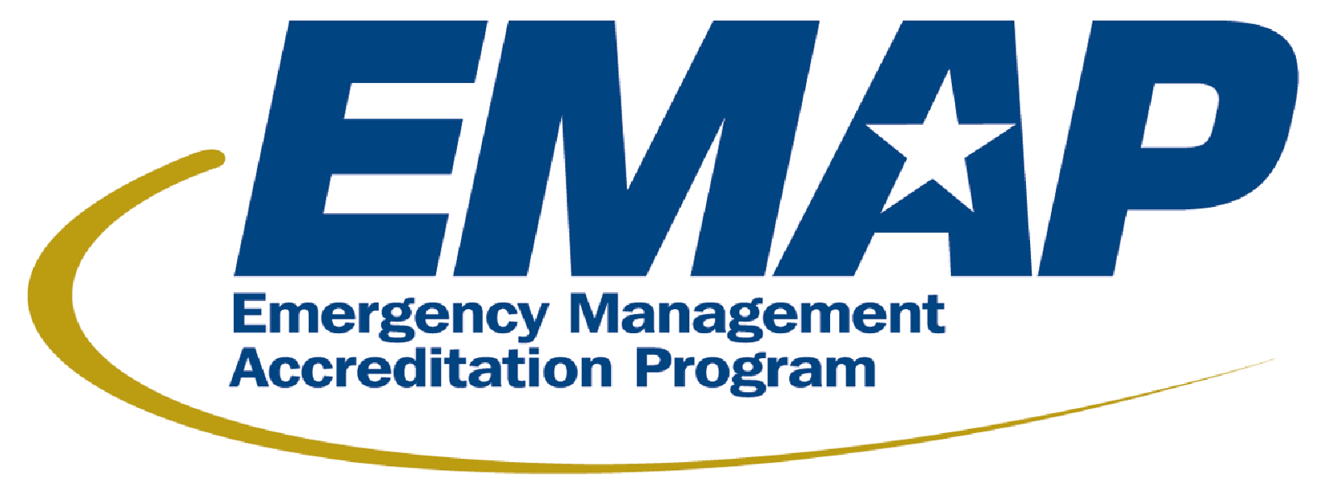

Media Release
For immediate release: March 26, 2026
Contact: Nicole I. Livingston, emap@emap.org

Honoring Excellence in Emergency Management: Two Programs Accredited

FALLS CHURCH, VA. – The Emergency Management Accreditation Program (EMAP) is thrilled to recognize the following emergency management programs that have achieved accreditation: City and County of Denver, Colorado, and Gwinnett County, Georgia.

“We congratulate these Programs on achieving EMAP accreditation—an accomplishment that reflects not only their dedication to preparedness and coordination, but also their commitment to continuous improvement,” said Jody Ferguson, Chair of the EMAP Commission and former Director of Pierce County, Washington Emergency Management. “By meeting rigorous national standards, these Programs demonstrate strong leadership and an unwavering commitment to the communities and stakeholders they serve.”

EMAP accreditation is a high honor awarded to emergency management programs that showcase their compliance with the Emergency Management Standard certified by the American National Standards Institute (ANSI). This achievement complies with EMAP’s mission to build safer communities through credible standards of excellence. These programs demonstrate accountability and continually identify areas for improvement to ensure they are prepared for any disaster – whether natural or technical. EMAP accreditation is not only an achievement, but a promise – a promise to maintain the highest level of service and readiness for the communities these programs serve.

Accreditation is achieved by a comprehensive evaluation process that includes self-assessment, documentation, and peer review to confirm the program’s alignment with the Emergency Management Standard. The Standard serves as a tool for those seeking to enhance their disaster preparedness and response systems. Accreditation is valid for five years. Programs must maintain compliance and undergo reassessments to retain their accredited status.

For Programs that earn accreditation, this achievement is not just a one-time success, but a continuous commitment. This ongoing dedication demonstrates that the program remains committed to upholding the high standards established by the Emergency Management Standard.

EMAP’s goal is to transform emergency management programs. These Programs must collaborate with various agencies, personnel, and resources to achieve success in the accreditation process. The Emergency Management Standard is designed for Programs of all sizes, populations, risks, and resources to use as a blueprint for improvement and compliance. It evaluates 17 key areas, including planning, resource management, training, communication, and administration.

EMAP remains the foundation of the nation’s emergency preparedness system, as it is the sole accreditation process for emergency management programs.

For more information and to view the complete list of accredited programs, please visit emap.org.

